NETFLIX CONTENT ANALYSIS DASHBOARD

Developed Using Power BI

Submitted By:
Yuva Teja
Roll No: 226Q1A4637

Department of Computer Science
KIET Engineering College

Academic Year: 2025–2026

TABLE OF CONTENTS

1. Introduction
2. Objectives
3. Dataset Description
4. Data Cleaning Process
5. Dashboard Creation
6. Dashboard Visualizations
7. Findings
8. Conclusion
9. References

INTRODUCTION

Netflix is one of the world's largest streaming platforms.This project analyzes Netflix content using Power BI.The dashboard provides insights into content distribution,ratings, countries, and release year trends.
OBJECTIVES

• Analyze Netflix content distribution.
• Compare Movies and TV Shows.
• Identify top content-producing countries.
• Analyze content ratings.
• Study release year trends.

DATASET DESCRIPTION

The dataset contains information about Netflix movies and TV shows.

Attributes:
• show_id
• type
• title
• director
• cast
• country
• release_year
• rating
• duration

Total records: 8,809
DATA CLEANING PROCESS

• Imported the dataset into Power BI.
• Checked for missing values.
• Removed errors.
• Corrected data types.
• Converted release year to numeric format.
• Prepared the cleaned dataset for analysis.

DASHBOARD OVERVIEW

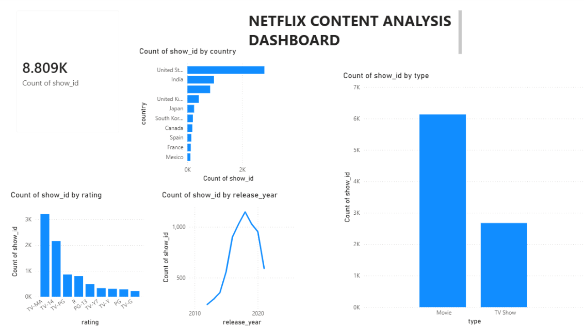
Total Titles Card
This card displays the total number of Netflix titles,
which is 8,809.

Country Chart
This chart shows the countries producing the highest
amount of Netflix content.
Type Chart
This chart compares Movies and TV Shows.
Rating Chart
This chart displays the distribution of content ratings.
Release Year Chart
This chart shows Netflix content trends over time.

FINDINGS :
• Total Netflix titles: 8,809.
• Movies dominate with 6,131 titles.
• TV Shows account for 2,676 titles.
• United States contributes the highest content.
• TV-MA is the most common rating.
• Netflix content peaked around 2019–2020.

CONCLUSION
The Netflix Content Analysis Dashboard providesvaluable insights into Netflix's content library.The analysis reveals that movies dominate the platform,the United States contributes the highest amount of content,and content production significantly increasedbetween 2015 and 2020.

REFERENCES
• Netflix Dataset (Kaggle)
• Microsoft Power BI Documentation

